

Omar Salah Massoud

Group B26- Final project report 2020

The main objective of this project is to control appliances in smart home using mobile app via Bluetooth.

First of all we had two ECU , the first one received controls from the Bluetooth devices and send signals to the second ECU via SPI communication interface. The second ECU in turn controls the actuators.

I used Proteus to simulate the mentioned system as follows:

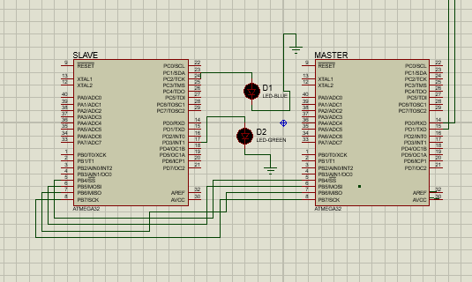

The master and the slave are connected by the MISO,MOSI,SS,SCK pins as the use SPI. Also the slave is connected to two leds as they represent the actuators.

Now we have to connect Bluetooth devices to the Master,

First I downloaded the Bluetooth library to the proteus and used HC-05 devices 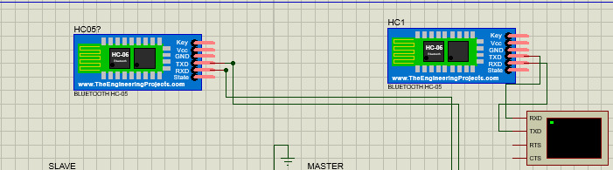

The first Bluetooth devices was connected to the ECU via UART interface (to the RX and TX) and the second one was connected to virtual terminal in order to send commands to control the actuators.

The trick was to connect the two Bluetooth devices together. That’s why a small software was downloaded and the communication between virtual coms was as follows:

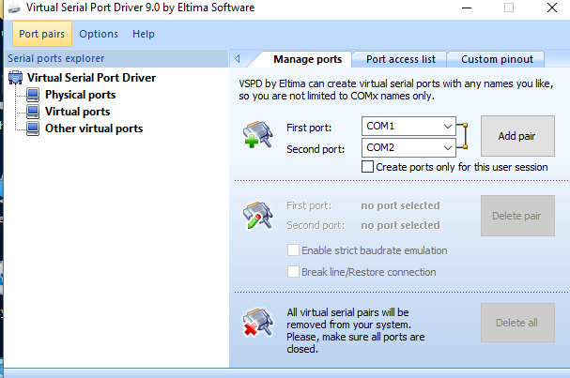

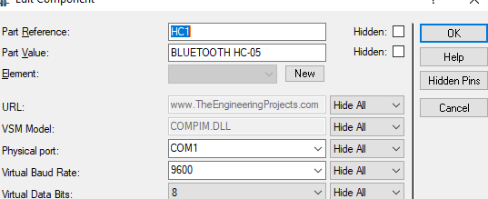

I set the Bluetooth device connected to the virtual simulator to be connected to physical port Com1

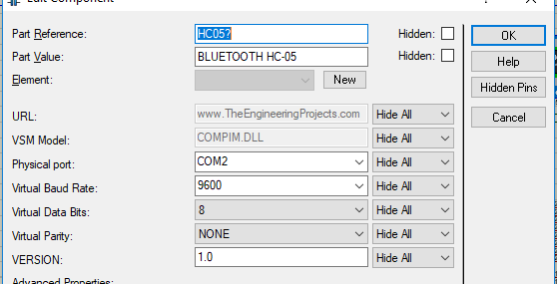

And the second one(which is connected to the ecu) to Com2.

In the code: I set that whenever the user writes ‘1’ In the virtual terminal, the output should be high :

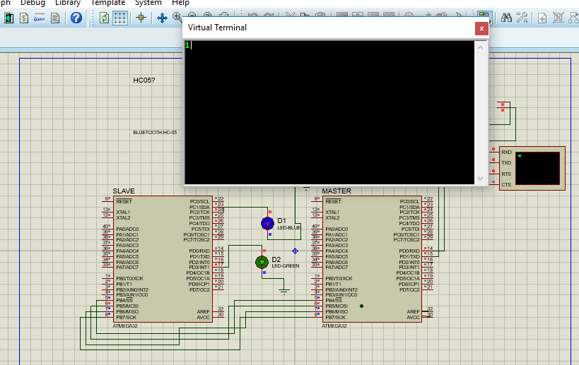

and whenever the user writes ‘2’ In the virtual terminal, the output should be Low

as follows :

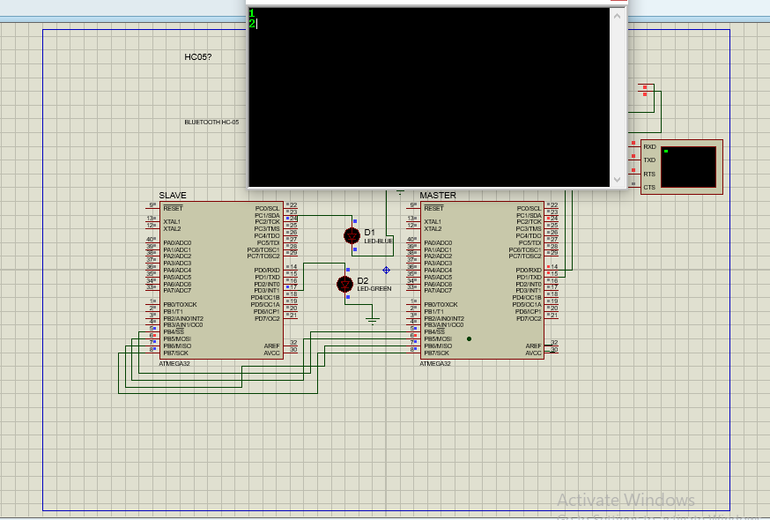

The next is a scheme of all the figure and the connections:

